Systems Analysis and Design I
Online Shopping
Birkbeck, University of London.

Group C5, Project Report.

Group Members
Name | Student ID
Salmaz Zaman | 13606044
Imranz Zaman | 13606172
Rayhan Uddin | 13502443

Project Management
UML Tool: Visual Paradigm
Project Management Tool: GitHub project
Version Control: GitHub
Repository: https://github.com/salmazzaman/bbk-sad-c5

Contents
Contents 3
1.0 Summary 4
2.0 Functional Requirements 4
3.0 Use Case Modelling 5
3.1 Actors 5
3.2 Use Cases 5
3.3 Use Case Description 6
3.4 Use Case Diagram 12
4.0 Activity Modelling 12
4.1 List of actions found at #4 use case Order Configured Computer 12
4.2 Activity diagram for #4 use case Order Configured Computer 14
5.0 Class Modelling 14
5.1 Entity classes 14
5.2 Class Diagram 15
6.0 Interaction Modelling 16
6.1 Sequence Diagram for Action “View Computer with Current Configuration” 16
6.2 Communication Diagram from Sequence Diagram 16

Online Shopping System

1.0 Summary

The project aims to develop a web based online shopping system to help a business who primarily manufacture and sell computers. The system should allow customers to view, select and purchase computers directly from the manufacturers website. All computers need to be categorised in three groups and they are 1. Servers 2. Desktops 3. Laptops. Customers can either purchase his desired computer as they are presented on the frontend, or they can customize their order using the system if they wish to get different configuration. The system should alter the price of the computer after calculating price of newly added components.
To complete the ordering process, the customer will be asked to provide payment details along with delivery address. The system must verify these credentials and if they are correct the order gets recorded, then the system will issue a confirmation email to the customer. The confirmation email will hold order details to track its status. Acceptable payment methods are credit card and cheques. Verification of these two payment methods are different, as a result the system should have separate flow of works for them.
After the payment verification is completed, the salesperson then forwards the order to the warehouse and prints invoice.

2.0 Functional Requirements

- The customer views the standard configuration of the chosen server, laptop or computer on the manufacturers online shopping webpage along with the costs.

- Customer wishes to view details of the configuration and may have the thoughts of purchasing it default or changing the configuration to match their satisfaction. The costs will be calculated upon the customers requirement.

- Customer either orders the required essential online or they may request to speak to a salesperson, so they are able to get the relevant details provided about the order and discussing prices before an order is ready to take place. It is evident that the salesperson will need an interface to record the order on behalf of the customer.

- To place an order, an online form must be filled out by the customer along with the invoice address, method of payment (credit cards, cheques) and shipment.

- As soon as the customer’s order gets recorded onto the system, the salesperson will send an electronic request to the warehouse with the details of the ordered configurations.

- The relevant purchase details that will be required by the customer such as the order number and the account number is mailed to the customers email address so that they will be able to check their order status online.

- The invoice the salesperson sent is received by the warehouse and the required essentials are shipped out to the customer.

3.0 Use Case Modelling

3.1 Actors
Primary actors of the system are customer, salesperson and the warehouse.
Customer: Anyone using the web system to purchase a computer.
Salesperson: Company employees who have access to the system.
Warehouse: Responsible for managing inventories and shipping computers.

3.2 Use Cases
Use Case | Actor | Use case
1 | Customer, Salesperson | View computer with default configuration
2 | Customer, Salesperson | Change components of the computer
3 | Customer | Request Call back
4 | Customer | Order (submits without option to add discounts)
5 | Customer, Salesperson | View order status
6 | Salesperson | View orders
7 | Salesperson | View call back requests
8 | Salesperson | Record Order (has option to add discounts)
9 | Salesperson | Verify Payment
10 | Salesperson | Print Invoice
11 | Salesperson | Send computer request to warehouse
12 | Salesperson, Warehouse | Update order status
13 | Warehouse | View Orders from Salesperson

3.3 Use Case Description

Use Case #1 | View computer with default configuration
Brief Description | Actor browse computers and selects desired computer and view its details.
Actors | Customer, Salesperson
Pre-Conditions | Actor visits the web page
Main Flows | - Computers are displayed in a list.  - Presses “view details” button of a computer.  - Single computer page loads, this has full details and default components of the requested computer.
Alternative Flows | - List computers from a single category by selecting appropriate category from 3 given categories- a) Laptop b) Desktop c) Server
Post-Conditions | If the use case is successful, a database query will be sent to request details of a single computer.

Use Case #2 | Change components of the computer
Brief Description | Actor modify component set of the computer and system calculates price based on modifications.
Actors | Customer, Salesperson
Pre-Conditions | Actor is in the single computer page.
Main Flows | - Add new components.  - View updated computer details.
Alternative Flows | - Replaces default components
Post-Conditions | If the use case is successful, then system will add new components or replace default components of the requested computer and re-calculate the price.

Use Case #3 | Request Call back
Brief Description | Request Call back
Actors | Actor enter his details and submits a form to request call back.
Pre-Conditions | Customer is on request call back page
Main Flows | - Customer fills out name and telephone number  - Submits the form
Alternative Flows | - Customer does not complete required fields  - Submits the form  - System shows validation error.
Post-Conditions | If the use case is successful a database entry is made with the customers’ requests for a call back, otherwise validation error is shown to the customer.

Use Case #4 | Order Configured Computer
Brief Description | Actor submits order using the frontend interface.
Actors | Customer
Pre-Conditions | Customer is on the computer details page.
Main Flows | - View the computer with current configuration  - Add computer to the cart.  - Page refreshes and computer is added to the cart.  - Goes to pay now page.  - Inserts shipping address  - Selects payment method.  - Inserts payment details  - Submits the order.  - Receives confirmation email with payment verification information and order number.
Alternative Flows | - Customer continues shopping.
Post-Conditions | If the use case is successful, the order is recorded in the database. If not, then the state does not change.

Use Case #5 | View order status
Brief Description | Actor uses order number to view its status. Status are categorised in three categories and they are a) Order received b) On its way c) Delivered
Actors | Customer, Salesperson
Pre-Conditions | - Order must be recorded.  - Order number must be present.  - Payment must be verified.  - Actor must be on the Order status checker page.
Main Flows | - Inserts valid order number in the form.  - Submits the form  - View order status
Alternative Flows | - Inserts invalid order number in the form  - Submits the form  - System displays error.
Post-Conditions | If the use case is successful, then Actor is presented with the status of the order.

Use Case #6 | View orders
Brief Description | Actor views list or all recorded order.
Actors | Salesperson
Pre-Conditions | - System has at least one order.  - Actor is logged in as salesperson.  - Actor is on the order list page.
Main Flows | - View orders in a list  - View individual orders by clicking view details button.
Post-Conditions | Actor views orders.

Use Case #7 | View call back requests
Brief Description | Actor views list of all call back requests made using frontend request call back form.
Actors | Salesperson
Pre-Conditions | - There is at least one call back request in the system.  - Actor is logged in as salesperson
Main Flows | - Visits the page call back request page  - System produces list  - View the list
Post-Conditions | If the use case is successful, then the system produces all call back requests in a list which contains name and phone number of each requester.

Use Case #8 | Record Order
Brief Description | Record Order (has option to add discounts)
Actors | Salesperson
Pre-Conditions | - Customer has made a request call back  - Actor is taking the order by calling the customer.  - Actor is logged in as salesperson  - Actor has already selected computer configuration.
Main Flows | - Add computer to the cart.  - Page refreshes and computer is added to the cart.  - Goes to Record payment page.  - Inserts shipping address.  - Selects payment method.  - Inserts payment details.  - Submits the order.  - Forward confirmation email to customer which has payment verification information and order number.
Alternative Flows | 3. Actor negotiate the price and adds discount  4. System re-calculates computer price
Post-Conditions | If this use case is successful, a valid order is recorded in the system otherwise nothing changes.

Use Case #9 | Verify Payment
Brief Description | Actor verifies payment and updates status using radio buttons a) Payment verified b) Payment pending
Actors | Salesperson
Pre-Conditions | - A valid order is in the system  - Actor is inside the order detail page.  - Actor is logged in as salesperson
Main Flows | - View automated payment status from credit card API for the order.  - Update payment status.
Alternative Flows | - In case of cheque payment, the salesperson will have to manually verify the cheque by cashing the cheque in a bank.  - Update payment status.
Post-Conditions | Payment is verified, status is updated.

Use Case #10 | Print Invoice
Brief Description | Actor prints invoice for individual order.
Actors | Salesperson
Pre-Conditions | - Payment is verified.  - Actor is logged in as salesperson  - Actor is in the order details page of an individual order
Main Flows | - Press “Print invoice” button  - Invoice is printed

Use Case #11 | Send computer request to warehouse
Brief Description | Actor sends computer request to the warehouse using the system.
Actors | Salesperson
Pre-Conditions | - Payment verified  - Actor logged in as salesperson.  - Actor is in the order details page of an individual order.
Main Flows | - Press “forward order to warehouse” button Send order to warehouse.  - System sends the order to warehouse.
Post-Conditions | If the use case is successful, then the order shows up on warehouse list of order which they need to process.

Use Case #12 | Update order status
Brief Description | Actors uses Update order status
Actors | Salesperson, Warehouse
Pre-Conditions | - Logged in as either salesperson or warehouse staff.  - Actor is in the Order details page.
Main Flows | - Selects the order.  - Update order status a) Order received b) Order is on its way c) Delivered using radio button.  - Save changes.
Post-Conditions | Order status of the order is updated.

Use Case #13 | View Orders from Salesperson
Brief Description | Warehouse staff views all orders forwarded by salesperson
Actors | Warehouse
Pre-Conditions | - At least one order is in the list of orders sent by salesperson to be processed by the warehouse.  - Actor is logged in as warehouse staff.
Main Flows | - Loads the “view all orders” page.  - System loads all orders in a list.

3.4 Use Case Diagram

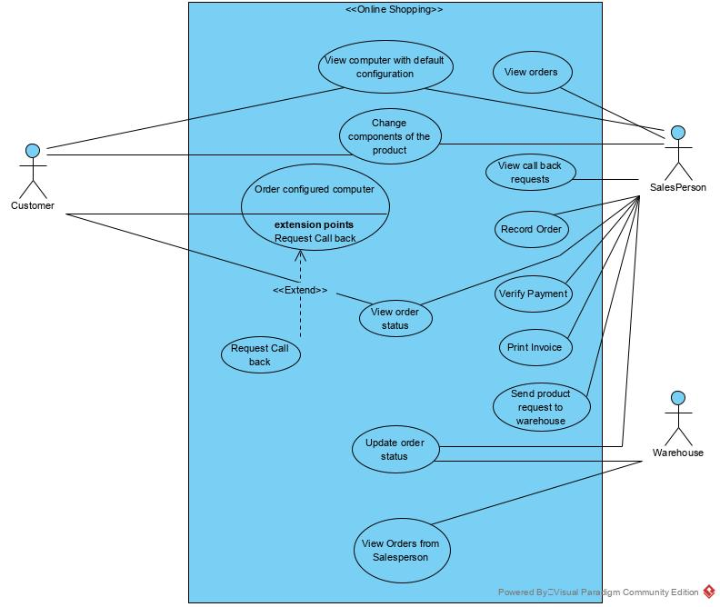
Figure 1 Use case model for the online shopping system

4.0 Activity Modelling

4.1 List of actions found at #4 use case Order Configured Computer

Flow:

- Customer views and selects the computer with current configuration.
- In order to aid the customer to send an item to the cart, the system will have a button beside the item. As soon as the customer presses the button, the system invokes an “add to cart” function which puts the item id, item price into a session array variable.
- Customer clicks the checkout link at the cart, to visit the pay now page. The page contains all items details, total price based on all items added to the cart. This information is provided using a function called “checkout page”.
- The checkout page should also contain a form that allows customer to insert shipping address, payment details, select payment method, and a button to submit the form, this invokes “get submit request” function. The system will validate the input and stores the order into the database.
- System then sends a confirmation email containing order number and instruction to check its status.
From above flow, we have got following actions
- View computer with current configuration
- Add to cart
- Load checkout page request
- Display purchase form
- Get submit request
- Validate inputs.
- Store the order into database.
- Send confirmation email.

Activity diagram for #4 use case Order Configured Computer

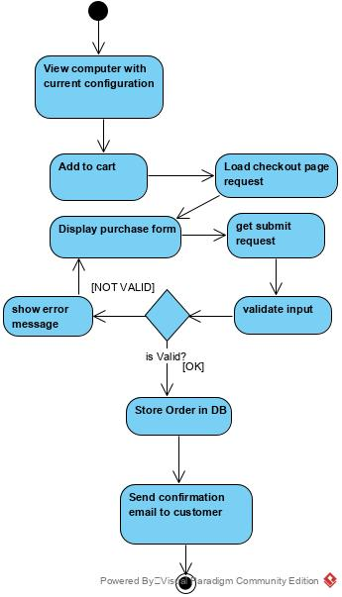
Figure 2: Activity Diagram

5.0 Class Modelling

5.1 Entity classes
From the requirement analysis section, we have found following entity candidates. They are then divided into parent child relationship to make use of OOP inheritance.

- Customer
- Computer
  - Default computer
  - Configured computer
- Order
- Invoice
- Payment
- Configuration
- Employee
  - Salesperson
  - Warehouse

5.2 Class Diagram
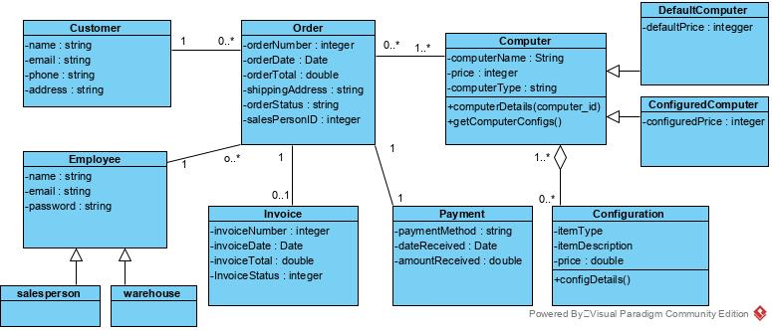
Figure 3 Class Diagram

6.0 Interaction Modelling

6.1 Sequence Diagram for Action “View Computer with Current Configuration”

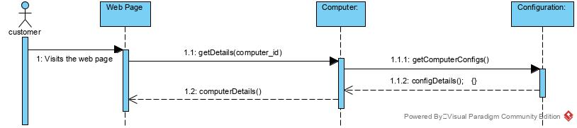
Figure 4 Sequence Diagram

6.2 Communication Diagram from Sequence Diagram

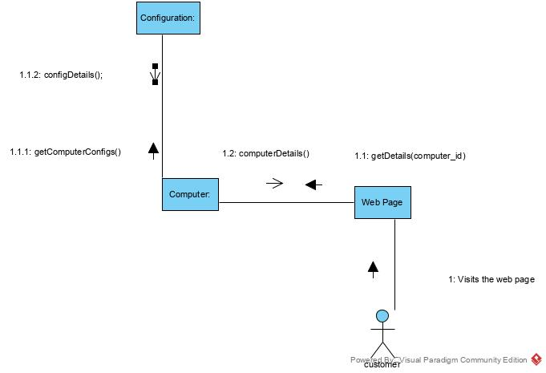
Figure 5 Communication Diagram

